Unofficial Unconference Conversation Guide
Hi! We designed this Conversation Guide to help you navigate the great, confidential conversations you’re about to have at the Unofficial Unconference. It covers all the essentials of how we run our two types of conversations: Show & Tells and Unconferences.
If you have any questions, we’re always available to help – just call us at 512-651-4800 or email us at members@socialmedia.org.

Table of Contents
- Show & Tell
  - Room Setup……………………………………………….. Page 2
  - Conversation Execution……………………………… Page 2
- Unconference
  - Room Setup……………………………………………….. Page 3
  - How to Curate Topics…………………………………. Page 3
  - Conversation Execution……………………………… Page 4

1. Show & Tell
Room setup
The room should be set up with the presenter at the front of the room (center), with the screen off to the side. The moderator is nearby to help start and end the session, and a helper sits at the front of the room to help the speaker track time.
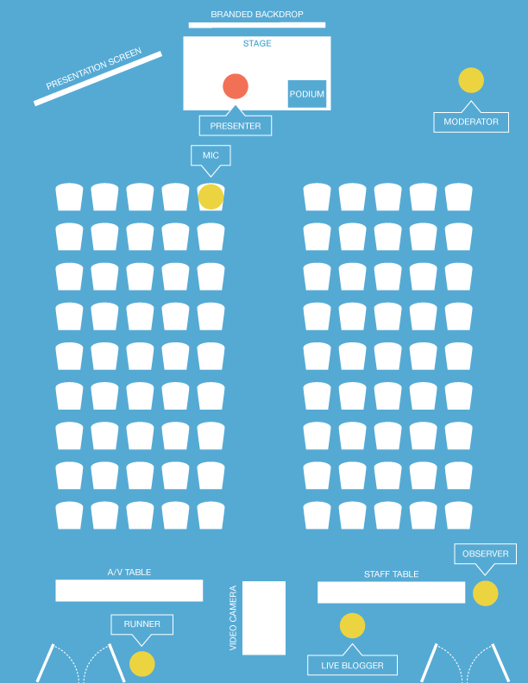

Conversation execution
Show & Tell talks are 20 minutes, followed by 10 minutes of Q&A.
- Before the session, prep the speaker on timing and Q&A process; confirm slides are setup and ready.
- Start session by closing doors to the room and welcoming the audience (1 minute before actual session start time).
- Introduce the speaker.
- After 20 minutes, thank speaker and begin 10-minute Q&A.
2. Unconference
Room setup
Chairs are distributed in the corners of the room (we recommend about 10 chairs per corner). An easel and flip chart in each corner help participants take notes (and help you write the topic). Extra chairs are helpful to have available in case a particular topic is popular and you need to quickly grab more.
The Unconference agenda board is clearly visible so participants can see the upcoming topic schedule.
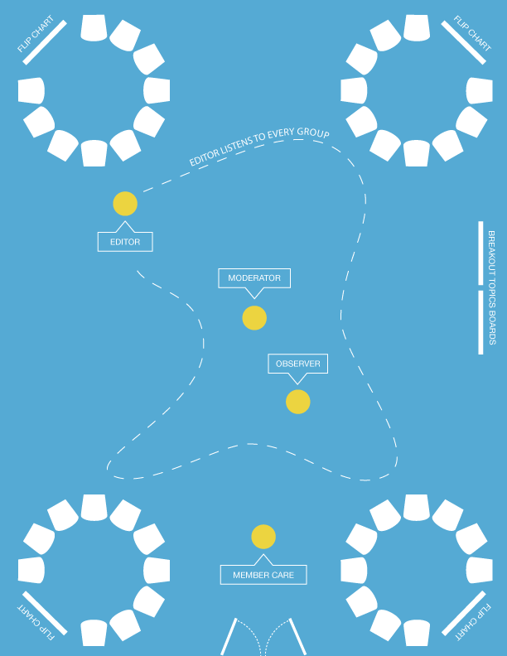

How to curate topics
Your goal is a good balance of senior-level topics in every round. You know you're doing well if each topic in a round has about the same number of people.
Step 1. Consolidate, de-duplicate, and pick the best senior topics.
You will get many more topics than you have slots for. Start by consolidating, grouping, and de-duping similar topics. For example, you may get three topics like: "How are you using LinkedIn?", "LinkedIn content strategy", and "LinkedIn advertising – worth it or not?". You could consolidate these as one topic, "Managing LinkedIn" and then list those separate topics as bullet points below it. (This way, more people's submissions make the cut and the group will have a better discussion with more to talk about.)
More tips:
- Ask, "What is the leadership/strategy angle on this topic?"
- Avoid narrow or extremely specific topics – they often don't have enough to talk about.
- Avoid topics that we've discussed in depth earlier in the day.
Step 2. Put your selected topics on the board.
Take your curated topics and put them on the board. Don't worry about order yet, just get them up there.
Step 3. Arrange to give a good mix of topics each round.
Spread out the topics so that each round has a really good mix of different issues. Try to get a BtoB, regulated, or similar in each round to give those folks an option.
Avoid having two similar topics in the same round. For example, don't have two platform conversations ("Facebook management" and "Twitter strategy") in the same round. Same for topics like vendors, tools, etc. Why? Because often the same people are interested in those topics – spreading them across rounds gives them more options.
Conversation execution
Unconferences are 30-minute small group talks. The standard format is 4 rounds, with 4 topics each (but you can adjust based on timing and number of people in attendance).
There is no moderator, and members choose the topic they want to join at the start of each round.
- Use the Unconference script to explain how everything works.
- Manage the room by ensuring participants are seated properly / bringing chairs over if needed -- as chairs fill up, bring more chairs over / pay attention that everyone’s in the circle (asking people to shift around to make room if necessary).
- At the beginning of a round, hover and use body language near groups to help them get started. If they're off to a slow or casual start, try asking someone "So, how do you "---topic---?" to get chatter going.
- During a round, monitor and help ensure conversations are flowing and that everyone is able to participate in each group.
- Give a 5-minute warning before the session ends. When the session time is up, open the doors. People often continue to talk, and that's OK. The next round should start promptly on time.

