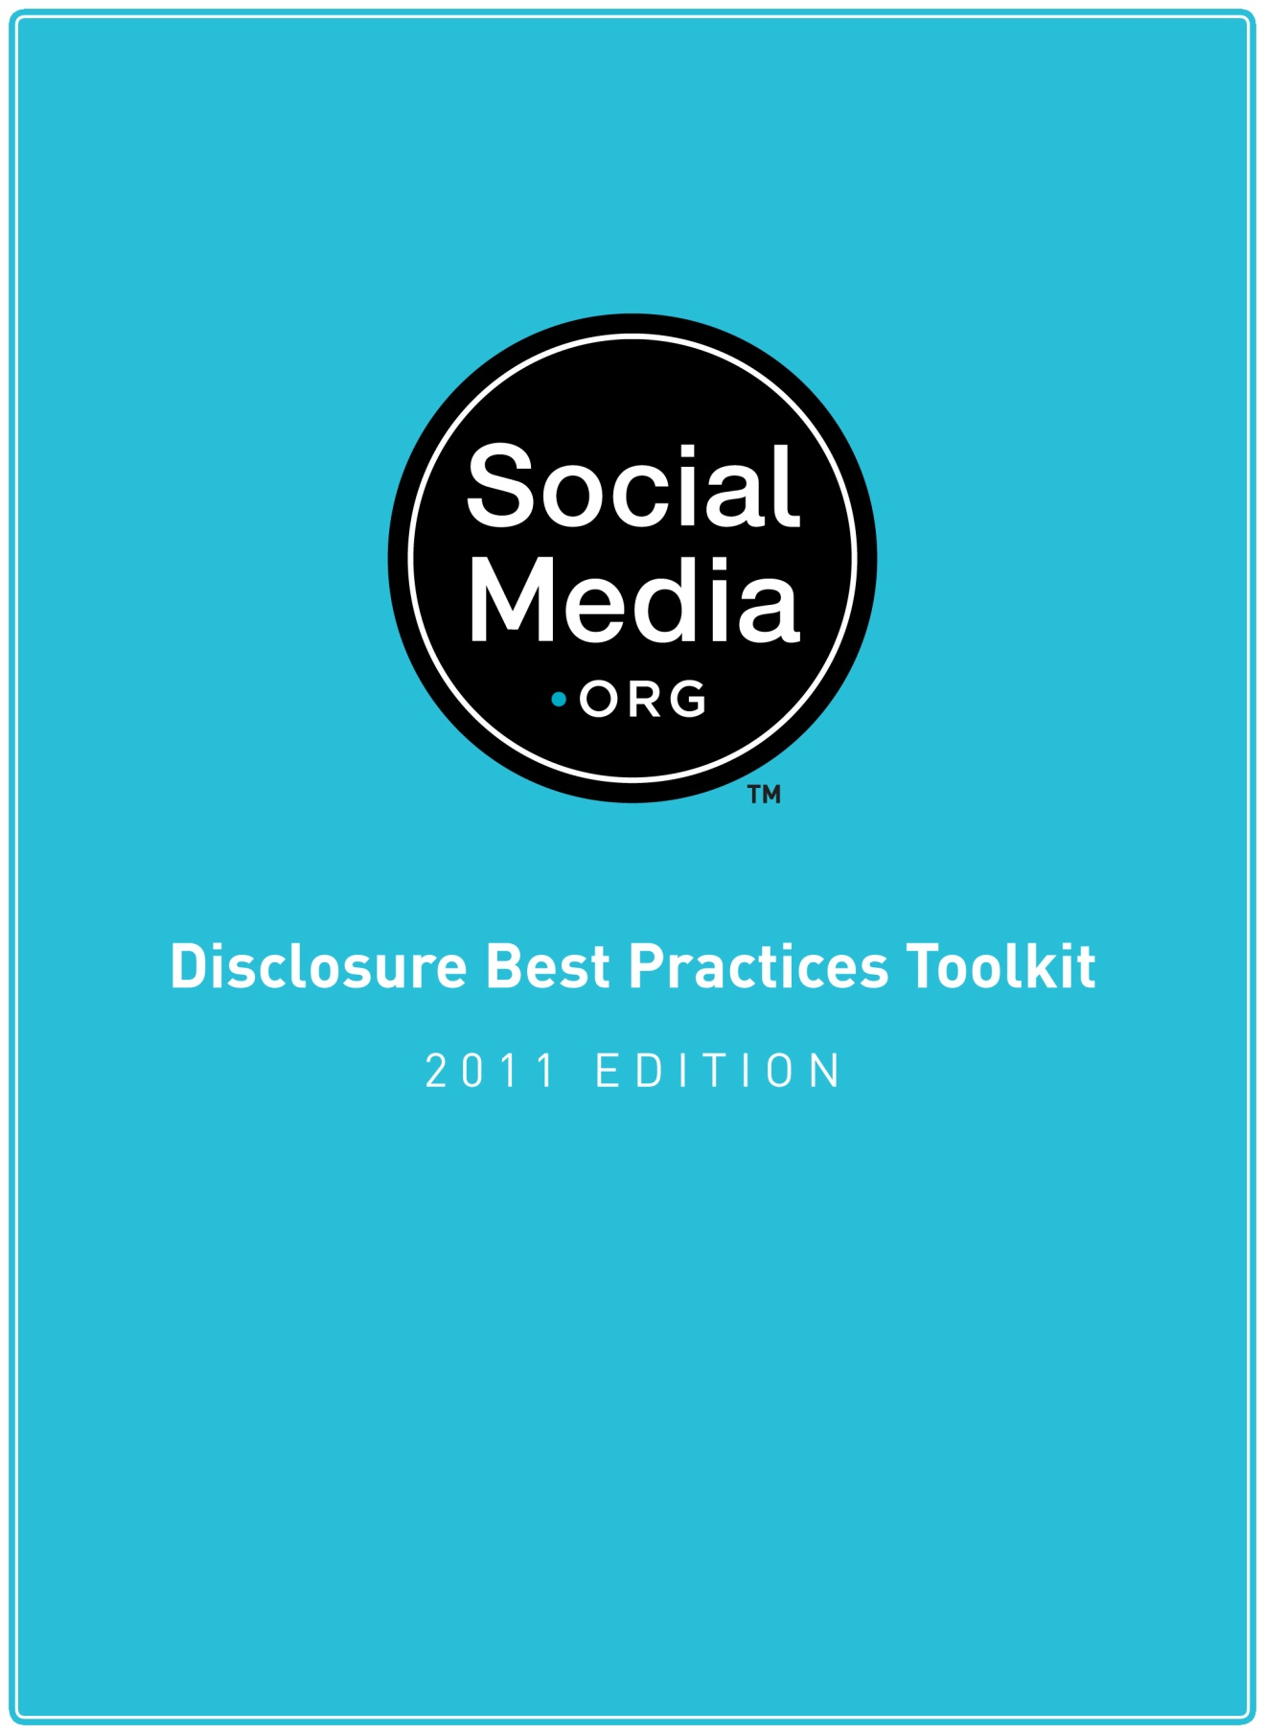
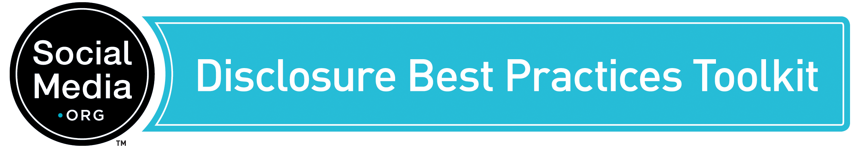

Introduction
This document is a series of checklists to help companies, their employees, and their agencies create social media policies.
Our goal is not to create or propose new industry standards or rules. These checklists are open-source training tools designed to help educate employees on the appropriate ways to interact with the social media community and comply with the law.
When we first released the Toolkit in July 2008, many members of the social media community saw these issues as a matter of opinion or intellectual debate. With the FTC's October 2009 release of the Guides Concerning the Use of Endorsements and Testimonials in Advertising (link), it's clear that proper social media ethics are a matter of law, not personal preference.
SocialMedia.org's Three Guides for Safe Social Media Outreach summarizes the fundamental obligations required for marketers to stay safe:
- Require disclosure and truthfulness in social media outreach.
- Monitor the conversation and correct misstatements.
- Create social media policies and training programs.
The FTC has also made it clear that the best way to protect your company from legal trouble is by establishing formal disclosure policies for your staff, agencies, and subcontractors.

How to Use this Toolkit
- The Toolkit is a series of checklists to help you create a social media policy for your company.
- Use the checklists to make sure you are covering all the key requirements and risk factors.
- Discuss these issues with every department involved in social media: marketing, communications, legal, HR, sales, customer service, etc.
- Create a social media policy in the form that best fits your organization's specific needs and operations. The format isn't important. It can be a stand-alone policy or it can be integrated into existing policies.
- Create a training program to share the results with your entire company.
- Share your policies with your agencies, consultants, and contractors and insist that they meet or exceed your standards.
The Toolkit is not a policy or ethics code. SocialMedia.org is not an association, standards, or enforcement organization.

Scenarios Addressed
- Disclosure of Identity
- Personal and Unofficial Social Media Participation
- Social Media Outreach Campaigns
- Truthfulness
- Advocacy Programs
- Compensation and Incentives
- Agency and Contractor Disclosure
- Vendor Questionnaire
- Monitor and Respond
- Policies and Training
- Creative Flexibility
- General Best Practices

This is an Open Source Document
This is a living document that will continue to evolve with community feedback and participation. Share and change this document as much as you like. It is licensed under a Creative Commons Attribution 3.0 Unported License. Please attribute SocialMedia.org and link to www.socialmedia.org/disclosure. We also encourage you to share your changes with the group by emailing editor@socialmedia.org.

Frequently Asked Questions

What is the purpose of these guidelines?
- Create a training tool
- Set a baseline of best practices
- Educate companies that are creating a social media policy for the first time
- Simplify a complicated topic

Are these rules mandatory or binding?
No, these are best practices for developing your own internal guidelines. SocialMedia.org is not a trade association or standards body, so we don't have the mandate or authority to set binding rules. We are a community that enables companies to learn from each other and collaboratively develop best practice recommendations.

Are you regulating social media?
No, not at all. This is an open-source training tool for companies that want to learn the right way to interact with social media. We are teaching and sharing our experiences.

What is SocialMedia.org's role?
We are a community of big brands that share insights and experiences with each other. We drafted this document to make it easier to share our learnings with everyone.

How does this relate to the FTC's rules?
The FTC specifically recommends that companies create a formal social media policy. This Toolkit helps you do just that. The checklists here will help you ensure that you have all your bases covered.

Are you accepting feedback?
Yes. We welcome and invite all interested parties to add their opinion and contribute toward improving the guidelines. We'll continue to update the Toolkit based on community feedback.

Disclosure Best Practices Checklist 1:
Disclosure of Identity
Focus: Best practices for how employees and agencies acting as official corporate representatives disclose their identity when using social media.

When communicating via social media on behalf of our company or on topics related to the business of our company, we will:
- Disclose who we are, who we work for, and any other relevant affiliations from the very first encounter.
- Disclose any business/client relationship if we are communicating on behalf of another party.
- Ensure that all disclosure meets the minimum legal standard by being a) clear and conspicuous, b) understandable by the average reader, and c) clearly visible within the relevant content.
- Require all employees to disclose their employer when using social media to communicate on behalf of the company or about company-related topics.
- Make certain that disclosure is sufficient so that the average reader understands that our company is responsible for the content, while they are reading the content.
- Comply with all laws and regulations regarding disclosure of identity.
- Properly use pseudonyms and role accounts:
  - (Option A) Never use a false or obscured identity or pseudonym.
  - (Option B) If aliases or role accounts are used for employee privacy, security, or other business reasons, these identities will clearly indicate the organization represented and provide means for two-way communications with that alias.
- Provide a means of communicating with our company in order to verify our involvement in a particular item of social media content.
- Instruct all employees, agencies, and advocates with whom we have a formal relationship on these disclosure policies and require them to comply.

Disclosure Best Practices Checklist 2:
Personal and Unofficial Social Media Participation
Focus: Best practices for employees who talk about company-related issues at any time in their personal social media participation.

For personal social media interactions:
- If employees write anything related to the business of their employer on personal pages, posts, and comments, they will clearly identify their business affiliation.
- The manner of disclosure can be flexible as long as it is a) clear and conspicuous, b) understandable by the average reader, and c) clearly visible within the relevant content. (Example disclosure methods could include: usernames that include the company name, or a statement in the post or comment itself, "I work for __<company>__ and this is my personal opinion.")
- Employees will specifically clarify which post or comments are their own opinions vs. official corporate statements.
- Writing which does not mention work-related topics does not need to mention the employment relationship.
- If employees post or comment anonymously, they should not discuss matters related to the business of their employer. If employer-related topics are mentioned, they should disclose their affiliation with the company.

Disclosure Best Practices Checklist 3:
Social Media Outreach Campaigns
Focus: Best practices for how businesses interact with external bloggers, social media sites, advocates, and communities.

When communicating to the social media community on behalf of our company, we will:
- Comply with all laws and regulations regarding disclosure of identity.
- Disclose who we are, who we work for, and any other relevant affiliations from the very first encounter.
- Proactively ask the recipient of the outreach to be transparent and fully disclose their relationship and communications with our company.
- Instruct them on the importance of disclosure and ask them to meet or exceed our disclosure guidelines.
- Never use off-topic or misplaced posts, comments, or tags for promotional intent.
- Never take action contrary to the specific boundaries, terms and conditions, and community guidelines set by each site, social network, or community.
- Not use services or technologies for mass-posting comments.
- Use extreme care when communicating with minors or using social networks intended for minors.
- Contractually guarantee that any third-party outreach program we participate in meets or exceeds our internal standards.

Disclosure Best Practices Checklist 4:
Truthfulness
Focus: Best practices for ensuring truthfulness and honesty in all social media communications, publications, and interactions.

When communicating via social media, or asking others to communicate via social media on our behalf, we will:
- Always be truthful.
- Ensure that information and claims provided to advocates, consumers, and social media sites are factual, honest, and accurate.
- Never ask someone else to deceive readers for us.
- Never ask advocates to write something they do not believe.
- Never ask advocates to endorse a product they have not used personally or create any other form of false endorsement.
- Insist that all opinions shared with the public express the honest and authentic opinion of the consumer or advocate without manipulation or falsification.
- Ensure that all individuals who are speaking for us are free to form their own opinions and share all feedback, including negative feedback.

Disclosure Best Practices Checklist 5:
Advocacy Programs
Focus: Best practices for disclosure when working with evangelists, advocates, or other members of a formal grassroots social media or word of mouth program.

In order to ensure full disclosure when working with advocates in a formal program, we will:
- Instruct advocates to disclose any formal or long-term relationship they have with us, including participation in any advocacy programs or campaigns.
- Instruct advocates to fully disclose any and all benefits, access, information, or anything else received as a result of participation that would not be provided to the general public.
- Ensure that all disclosure meets the minimum legal standard by being a) clear and conspicuous, b) understandable by the average reader, and c) clearly visible within the relevant content.
- Provide formal training to the advocates about proper disclosure practices.
- Discontinue relationships with advocates if they fail to disclose their relationship with us.
- Require that any intermediary helping us reach advocates is requiring their downstream contacts to meet or exceed our standards.
- Contractually guarantee that any third-party outreach program we participate in meets or exceeds our internal standards.

Disclosure Best Practices Checklist 6:
Compensation and Incentives
Focus: Best practices for disclosure when providing incentives to bloggers or other social media advocates.

When providing advocates with any form of compensation such as rewards, incentives, promotional items, gifts, samples, or review items, we will:
- Instruct advocates to fully disclose the source and nature of any compensation received.
- Ensure that all disclosure meets the minimum legal standard by being a) clear and conspicuous, b) understandable by the average reader, and c) clearly visible within the relevant content.
- Discontinue relationships with advocates if they fail to disclose their relationship with us and any compensation received.
- Set a formal policy on disposition of incentives. Examples of such policies include:
  - Review products can be returned at their own discretion.
  - Review products must be returned or paid for at fair market value.
  - Items of nominal value (low cost product samples or consumables) may be kept.
  - Review products should be returned, paid for, or retained by the blogger or social media advocate based on standards for the specific industry. (Examples: restaurant reviewers pay for the meal; tech reviewers return the product; hotels provide complimentary stays.)
- Communicate these policies clearly to the advocate in advance and require that they follow the policies in any resulting social media communications.
- Communicate that advocates will only use their own words to express their honest personal opinions. Advocates who receive compensation or samples are not obligated to comment at all, and they are free to comment in a positive, negative, or neutral fashion.
- Clearly separate advertising from editorial. Paid posts, comments, or reviews should be considered advertisements. They must clearly be labeled as such. At no time should paid advertisements appear to be social media content. Example: Paying for a blog post is deceptive because it is disguising advertising as editorial content. Even with disclosure, the average reader would assume it is a blog post containing the personal opinion of the author.
- Not manipulate advertising, link-trading, or affiliate programs to impact blogger income or traffic.

Disclosure Best Practices Checklist 7:
Agency and Contractor Disclosure
Focus: Best practices for social media vendors, agencies, and subcontractors that act on behalf of a company.

When using external agencies or personnel to communicate on our behalf, we will:
- Formally instruct agencies and all personnel working on behalf of our company on our disclosure requirements.
- Require agencies and agency personnel to meet or exceed our internal disclosure requirements.
- Require agencies to enforce these requirements on their subcontractors.
- Require agencies and their personnel to disclose their relationship with our company in a clear and conspicuous manner when conducting social media outreach.
- Inform our staff and agencies that the FTC has indicated the client is fully responsible and liable for all inappropriate actions of their agencies, their subcontractors, and the advocates they recruit.
- Publicly acknowledge when our agency and/or related parties act contrary to these policies and quickly take corrective action where possible.
- Always discuss and secure formal agreement on these practices before entering into a business relationship with an agency involved in social media.

Disclosure Best Practices Checklist 8:
Vendor Questionnaire
Focus: Questions to ask a social media vendor that may reveal a potential ethics problem.

Before working with a social media agency, we will ask:
- Does the agency have social media policies and ethics training programs?
- Has every person assigned to our account received formal social media disclosure training?
- Do they have procedures to train all subcontractors (and subcontractors' employees) assigned to our account?
- Do they have reporting and operational review procedures in place that will ensure full compliance with all social media disclosure standards?
- Do their personnel always disclose their relationship with us?
- Do they forbid the blurring of identification in ways that might confuse or mislead consumers?
- Do they keep detailed records of social media outreach, contacts, posts, and comments by their people?
- Do they have a plan to follow up on all outreach to ensure resulting posts and comments are properly disclosed?
- Do they forbid the use of expressly deceptive practices, such as impersonating consumers; concealing true identities; lying about factors such as age, gender, race, familiarity with or use of product; or other circumstances intended to enhance the credibility of the advocate while deliberately misleading the public?
- Have they previously engaged in unethical practices? If they have ever engaged in such practices in the past, do they now prohibit them, and will they guarantee that they will not use employees who have engaged in fraudulent practices to work on our behalf?
- Can we rely on them to raise the bar on social media ethics, or do we need to monitor them or their subcontractors closely?
- Do they meet or exceed our high standards of ethical behavior and practice, and are they willing to provide written guarantees for their own work as well as that of all subcontractors?

Disclosure Best Practices Checklist 9:
Monitor and Respond
Focus: Best practices to monitor the results of social media outreach to ensure proper disclosure and truthfulness, including best practices for good-faith efforts to attempt to correct misstatements and misrepresentations.

In order to correctly monitor our social media outreach for disclosure and factual errors, we will:
- Monitor the statements by our advocates that result from our communications and programs.
- Keep a record of advocates contacted by us, as well as the information and incentives provided to them.
- Attempt to correct any misrepresentations or inaccurate statements that result from our outreach.
- Attempt to correct any missing disclosure by our advocates or representatives.
- Keep a record of all attempts to correct errors.
- Discontinue any relationship with an advocate or representative who repeatedly fails to meet disclosure or truthfulness requirements.
- Set a policy that "we didn't know" is not acceptable at our company.

Disclosure Best Practices Checklist 10:
Policies and Training
Focus: Best practices for creating a social media policy and ensuring that all of our employees and representatives are fully trained.

We will:
- Maintain and enforce a formal social media policy.
- Train all employees who use social media as a part of their jobs.
- Train employees about appropriate use of social media not directly related to their jobs.
- Educate employees about when personal use of social media requires disclosure.
- Track employee use of social media for activity that violates our social media policy.
- Make social media training a part of our standard HR procedure.

Disclosure Best Practices Checklist 11:
Creative Flexibility
Focus: Best practices for artistic/entertainment situations where temporarily obscuring the source of social media communications is necessary and appropriate.

Disclosure may be delayed temporarily to allow for creative freedom if it meets all of the following criteria:
- The content is clearly part of a game, mystery, or other project that is intended for entertainment purposes.
- It is apparent to the average reader that there is a business/marketing purpose to the project.
- The purpose of the delayed disclosure is not to enable corporate representatives to pose as consumers.
- The sponsor will be revealed within a reasonable period of time.

Example: Creating blogs to promote a movie.
- CORRECT: An obviously fictional blog where someone writes that they may have discovered aliens in their house to promote a science fiction movie.
- CORRECT: A blog is "written" by a character that is clearly fictional.
- CORRECT: Clues in a mystery or alternate-reality game.
- INCORRECT: A blog where an author is impersonating an uninvolved consumer and writing: "I'd love to go see this movie."

Disclosure Best Practices Checklist 12:
General Best Practices
Focus: Best practices for creating an overall atmosphere of ethical, transparent disclosure.

To follow the spirit of our policy, we will:
- Err on the side of over-disclosure. If a reader would be surprised to discover a fact later, we will disclose it up front.
- Use the space available for improved disclosure. When space is limited (such as on Twitter), disclosure may be minimal, but for media with no space limits (such as on blogs, Facebook, or comments on other forums) we will provide complete disclosure in the comment.
- Make certain that all disclosure is sufficient so that the average reader clearly understands that our company is responsible for the content we initiate, while they are reading the content.
- Ensure that the agencies and contractors working for us are meeting or exceeding our standards, not asking us to lower them.
- Ask: Would we be uncomfortable if our family and friends were involved in this campaign?
- Ask: Is there anything about this project we would be embarrassed to discuss publicly?
- Ask: Would we consider this action with any other media, or are we looking for a social media loophole for a questionable action?

